**Abstract**

Countless everyday activities require us to coordinate our actions and decisions with those of other agents. Coordination not only enables us to achieve our goals efficiently, but has also been shown to boost prosocial attitudes such as *commitment*, leading people to continue investing time and effort into an interaction even when their motivation wavers. As of yet, however, little is known about the mechanism by which coordination generates commitment. To investigate this, we conducted two experiments using tasks representative of very different coordination problems: coordination of movement timing on a joint drumming task (Experiment 1) and coordination of decision-making on a joint object matching task (Experiment 2). In both experiments, the similarity of the participant and partner was manipulated by varying whether or not they had perceptual access to the participant’s workspace, and the participants’ attribution of (un)willingness to invest effort into the joint action was manipulated by varying whether or not the participant believed their partner had perceptual access. As a measure of commitment, we registered how many times participants pressed the spacebar on a subsequent task to earn points for their partner.

The results showed that participants were significantly less committed to earning points for the unadaptive partner than for the adaptive partner, but only when they believed that their partner was unwilling to adapt rather than unable to adapt. This finding supports the hypothesis that coordination generates commitment insofar as it provides a cue that one’s partner is willing to invest effort to adapt, and may therefore be viewed as a reliable interaction partner. Moreover, we demonstrate that this effect generalises across different classes of coordination problems.

*Keywords:* coordination, synchronization, decision-making, adaptivity, commitment, cooperation

**Significance statement**

The current study contributes new insights to our understanding of human social behaviour: both in our evolutionary past, and today. Specifically, we show that commitment, a cornerstone of both small- and large-scale social interactions, emerges through the process of adapting to accommodate each other’s actions and decisions in order to coordinate. Adaptation not only facilitates successful coordination in the here and now -- it also bolsters the commitment needed to plan and implement future interactions. Our findings elucidates how, in addition to monetary rewards, adaptation and other forms of effort investment in social interaction lay a foundation for short- and long-term cooperation. These insights are crucial to understanding why we humans endeavour to sustain cooperation even when we are in deep water and the tide is against us.

**Coordination generates commitment by signaling a willingness to adapt**

Coordination is ubiquitous throughout our day-to-day lives. During the daytime whether we are repairing an aeroplane, directing a movie, or even performing open-heart surgery, we coordinate actions and decisions with our work colleagues in order to make sure our job is done properly. In addition to helping us to achieve instrumental goals more efficiently than we otherwise could, the process of coordination is often experienced as being rewarding in itself: from singing together with the congregation at church, to dancing with friends or strangers at a nightclub, many cultural practices attest that people enjoy and value coordinating with others even in the absence of any instrumental goal. Moreover, there is a wealth of research showing that coordination generates important indirect benefits by boosting prosocial attitudes and motivations: strengthening social bonds [1], enhancing trust and rapport [2,3], and increasing cooperation and helping [4,5,6,7].

Building on this research, interpersonal coordination has also been shown to generate a sense of commitment leading people to persist longer on a boring or effortful task to benefit another agent [8]. This finding is particularly important insofar as commitment serves as a glue holding human social life together [9]. Commitment is crucial not only in sustaining small-scale social interactions unfolding over brief timescales, such as dancing or painting a house together, but also in providing the stability and predictability required for large-scale collective actions, such as combating climate change or pandemics, which involve sustained effort and personal sacrifice over longer timescales.

But what is it about being in a coordinated interaction that generates a sense of commitment? To address this question, the current study aimed to test two distinct, albeit compatible, hypotheses. The first of these is *the* *similarity hypothesis*. Itstates that coordination provides a cue to similarity, leading an agent to feel more committed towards the partner with whom one is coordinating. This is because those engaging in joint actions or in joint decision-making often have similar goals and exhibit similar movements. For example, it has been suggested that cueing similarity through coordination leads us to project our own positive traits onto the agent with whom we are coordinating [10], that it increases self-other overlap [11], or that it increases awareness of our relationship as interdependent units of a group [12].

The second hypothesis is *the effort investment hypothesis*. It states that successful coordination reflects a partner’s willingness to invest effort into the interaction, boosting an agent’s sense of commitment towards that partner. This is based on the observation that successful coordination requires agents to invest effort in order to make the interaction work. One instance of this is the fact that agents adapt to each other in order to ensure coordination success. By adapting their movements or their decisions, agents facilitate alignment with their partners, and can even adapt in ways that make their actions or decisions easier for their partners to align with [13,14,15,16,17]. This means that adaptation reflects an agents willingness to invest effort into an interaction, insofar as it requires an agent to incur an individual cost in order to reduce the (e.g. planning) costs for their partner and/or to increase the chances of jointly succeeding [18,19]. For this reason, an agent’s willingness to adapt may provide an important signal that she is a reliable interaction partner, and that it is therefore worth cultivating a collaborative relationship with her. This hypothesis is consistent with recent research demonstrating that when an agent invests effort in a joint action, this increases her partner’s sense of commitment towards the joint action and towards her, leading that partner to persist longer on boring or effortful tasks [20,21].

*The Current Research*

In most instances of coordination, adaptation as effort investment is confounded with similarity: by adapting to one another leads, two agents increase r the similarity between their actions or decisions. In order to tease apart similarity and willingness to invest effort, we therefore manipulated two factors separately. t. t. Firstly, we manipulated whether the participant interacted with a partner who was adaptive, and who therefore exhibited similar actions and decisions to the participant, or a partner who was unadaptive, and who therefore exhibiteddissimilar actions and decisions to the participant. Secondly, we manipulated whether participants were led to believe that their partner was able or unable to adapt to them, and consequently what inferences they were likely to draw from the interaction about their partner’s willingness to invest the effort required to adapt (Able-to Adapt belief condition, and Unable-to-Adapt belief condition). We reasoned that by leading participants to believe that their partner was unable to adapt,we would lead them to attribute the unadaptive partner’s lack of adaptivity to an inability to adapt. In contrast, we expected that by leading participants to believe that their partner was able to adapt, we would lead them to attribute the unadaptive partner’s lack of adaptivity to an unwillingness to invest the effort required to adapt

The similarity hypothesis predicts that participants’ commitment to their partners should increase as a function of the degree of similarity between the participant’s and the partner’s actions/decisions It does not provide any reason to expect that commitment should be modulated by any inferences that participants are led to draw about their partner’s willingness to adapt. According to the effort investment hypothesis, in contrast, commitment should depend upon participants’ inferences about their partner’s willingness to invest effort to adapt. In other words, the effort investment hypothesis e predicts that participants should be more committed to the adaptive partner than the unadaptive partner, but only when they believe that the unadaptive partner is able but unwilling to adapt.

In order to provide a general test of these hypotheses, we devised two separate experimental scenarios implementing two distinct forms of coordination: action coordination (Experiment 1) and decision-making coordination (Experiment 2). This allowed us examine whether any effects we may find would generalise across different coordination problems, in which adaptations may be informed by different processes (e.g. action prediction vs perspective taking), require different kinds of effort investment (e.g. physical vs mental effort), and yield different kinds of similarity (e.g. low-level perceptual similarity vs abstract similarity).

**Experiment 1**

In Experiment 1, we instructed participants to coordinate drum taps with two separate partners, and subsequently measured their level of commitment to each of these partners. We manipulated adaptivity, ensuring that one of the two partners was adaptive and the other was unadaptive, by manipulating whether the partner could hear their own taps only (and was therefore not able to adapt to the participant) or could hear both their own and the participant’s taps (and was therefore able to adapt to the participant). We expected this manipulation to have an impact on similarity: compared to the unadaptive partner’s taps, the timing of the adaptive partner’s taps would be more similar to the timing of the participant’s taps. In addition, we manipulated whether or not the participants believed that their partner could hear them (see left panel of figure 1 for a graphical representation of the design). We assumed that if participants believed that their partner could not hear them (Unable-to-Adapt belief condition), then they would attribute the lack of adaptivity to the partner’s inability to adapt under the circumstances. However, if participants believed that their partner could hear them (Able-to-Adapt belief condition), then they would attribute the lack of adaptivity to an unwillingness to adapt.

We then deployed a subsequent task - using persistence as a measure of commitment - in order to gauge the effect that the manipulations in the drumming task had on the participant’s commitment to their partners. Specifically, participants were asked to tap the spacebar in order to charge onscreen batteries for the adaptive partner, and for the unadaptive partner (eight batteries for each partner). Participants were led to believe that they were responsible for earning points for their partners. Moreover, they were instructed that each partner’s bonus payment for the experiment depended on how much they charged that partner’s batteries (see right panel of figure 1 for a graphical representation of the procedure).

If similarity generates a sense of commitment, we should expect that participants would charge the batteries more (thereby accruing more points) for the adaptive partner than for the unadaptive partner, irrespective of their beliefs about whether or not their partners were in fact able to adapt. However, if perceived willingness to adapt generates a sense of commitment insofar as it constitutes an investment of effort, we should expect that participants would charge the batteries more for the adaptive partner than the unadaptive partner, but only in the Able-to-Adapt condition -- i.e. only when they believed that their partners had the ability to adapt, thus attributed the unadaptive partner’s lack of adaptivity to an unwillingness to adapt.

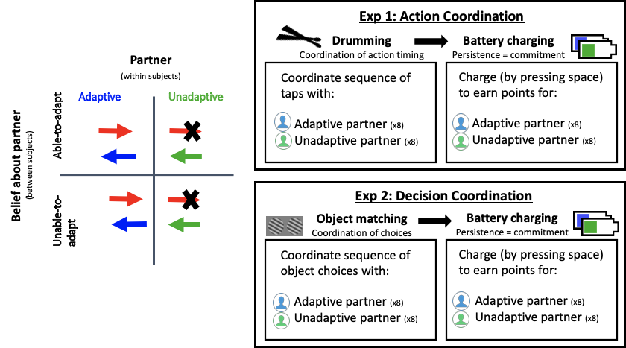

*Figure 1: The left panel depicts the design of the two experiments. The arrows represent the direction of information flow in the two experiments (Exp 1: tapping sounds, Exp 2: visual access to partners workspace). The red arrow represents the participant, the blue arrow represents the adaptive partner, and the green arrow represents the unadaptive partner. The right panel depicts the structure of both experiments.*

**Results**

In order to investigate the extent to which participants invested effort - by continuously pressing spacebar - to charge batteries for the adaptive partner (whose movement timing was similar to the participants movement timing on the drumming task) and unadaptive partner (whose movement timing was different to the participant movement timing on the drumming task) in the two conditions, we carried out a 2x2 mixed ANOVA with partner (adaptive, unadaptive) as a within subjects factor, and belief (Able-to-Adapt, Unable-to-Adapt) as a between subjects factor. The ANOVA revealed a significant main effect of partner, F(1,50) = 28.69, p < .001, η2 = .327, but no main effect of belief, F(1,50) = .016, p = .9, η2 = .001. Importantly, we found a significant interaction between partner and belief, F(1,50) = 9.16, p = .004, η2 = .104 (see left panel of graph 1), demonstrating that participants were relatively more committed to the adaptive partner than the undaptive partner when they attributed lack of adaptivity down to unwillingness to adapt, rather than inability to adapt. However, post hoc t-tests showed that participants charged the adaptive partner’s battery more than the unadaptive partner’s battery in both the partner able-to-adapt belief condition, t(25) = 4.63, p < .001, d = .91, and the partner unable-to-adapt belief condition, t(25) = 2.57, p = .011, d = .51, demonstrating that participants were overall more committed to the adaptive partner whose movement timing was more similar to to their own, than the unadaptive partner whose movement timing was dissimilar to their own, regardless of their belief about whether or not the unadaptive partner was in fact able to adapt. These results show that, though similarity may play a role in the emergence of commitment irrespective of any inferences about a partner’s willingness to invest effort by adapting, a partner’s willingness to invest effort to facilitate coordination is central to the development of a sense of commitment.

Considering the nature of the battery charging task, participants were likely to become bored and fatigued towards the end of the experiment, potentially leading to decreased persistence. Thus, in order to control for fatigue throughout the experiment, we carried out a linear mixed effects model, with number of spacebar presses as the response variable, partner and belief as fixed effects and trial number as a random effect. This analysis revealed a significant effect of partner, z = -3.572, p < .001, but no effect of belief, z = -.494, p = .622. However, there was an interaction between partner and belief, z = 2.339, p = .019, even when trial number was controlled for, demonstrating that our effects cannot be explained simply by differences in fatigue or decreasing motivation in the different conditions.

*Controlling for similarity*

In order to further disentangle the willingness to invest effort and the resulting similarity , we probed the extent to which the effect depends on how similar the two actors’ timing was, using asynchrony (timing of partner’s taps subtracted from timing of participant’s taps) in the drumming task as an index of similarity (lower asynchrony means more similarity regarding movement timing). Firstly, a 2x2 ANOVA on the asynchrony data yielded a significant main effect of partner F(1,50) = 25.69, p<.001, η2 = .338 but no main effect of belief, F(1,50) = .02, p = .89, η2 = 0, or no significant interaction between partner and belief, F(1,50) = .23, p = .63, η2 = .003 (see right panel of graph 1), demonstrating that patterns of asynchrony were the same in both conditions, meaning that the differences in similarity cannot explain the differences in commitment we observed between participants in the two groups.

We also carried out a linear mixed effects model (LMM), with number of space presses as the response variable, partner and belief as fixed effects adding asynchrony as a random effect, allowing us to control for any variability associated with similarity of movement timing, allowing us to isolate the effect of adaptivity. This analysis revealed a significant effect of partner, z=-2.168, p= .03, but no effect of belief, z =,-1.319, p = .187. Importantly, even with overall similarity controlled for, the interaction between partner and belief was still significant, z = 2.202, p = .028. Overall, this demonstrates that our findings cannot be explained by different patterns of movement timing similarity in the two groups, providing additional evidence that willingness to invest effort by adapting fosters commitment independently of similarity.

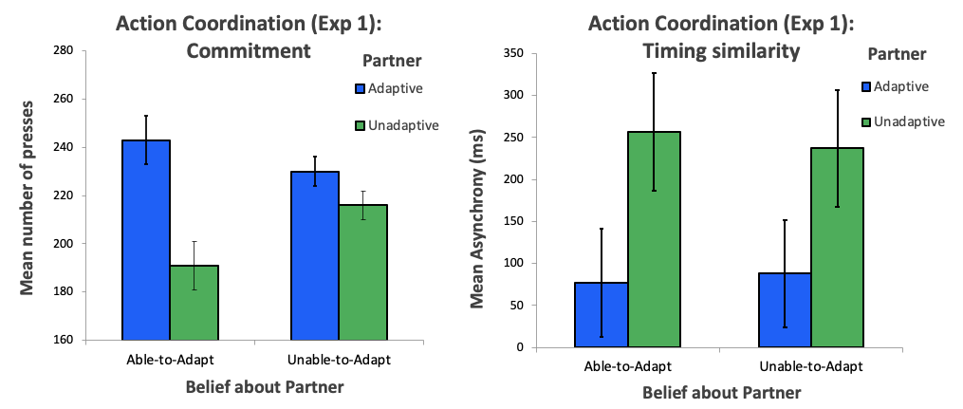

*Graph 1: Left panel displays commitment (indexed by persistence on the charging task) to the adaptive and unadaptive partner in the Able-to-Adapt and Unable-to-Adapt belief conditions. Right panel displays movement timing similarity (indexed by drumming asynchrony) with the adaptive and unadaptive partner in the Able-to-Adapt and Unable-to-Adapt belief conditions. Error bars represent within-subject confidence intervals.*

**Experiment 2**

Our first experiment demonstrated that coordination fosters commitment to an agent insofar as it provides evidence of that agent’s willingness to invest effort in a joint action by adapting the timing of their movements, and thereby signals that the agent is a reliable partner. Crucially, the effect of coordination upon commitment which we observed cannot be explained by the hypothesis that coordination provides a cue to similarity with the agent. In Experiment 2 we aimed to generalize this finding to other contexts beyond that of action coordination, which was the focus in Experiment 1.

Decision-making coordination, like action coordination, is a pervasive and important feature of every life -- from choosing to drive on the right (or left) side of the road, deciding what film to watch with one’s partner, and political parties forming strategic coalitions to enact their legislative agendas [17, 22, 23]. Moreover, it has also been shown that decision-making coordination, like action coordination, has positive effects upon agents’ prosocial motivations [24,6].

In contrast to action coordination, which requires an agent to employ action prediction mechanisms, and make physical adaptations to their movements on the basis of these predictions [25,26], decision-making coordination requires agents to employ mindreading mechanisms, and to tailor their decisions to the mental states of their partner [27,28]. Moreover, these two types of coordination yield different kinds of similarity, with action coordination leading to low-level perceptual similarity and decision-making coordination leading to a more abstract similarity, i.e. at the level of beliefs, desires, or worldview.

Thus, we designed Experiment 2 to investigate how similarity and investment of effort contribute to the development of commitment towards an agent with whom we coordinate decisions. Participants first coordinated decisions with either an adaptive or an unadaptive agent, and then performed the same battery-charging task as in Experiment 1, enabling us to measure their commitment to each of the two partners.

For the coordination task, the participant and the partner each had a workspace containing an array of three Gabor patches with varying orientations. On each trial, the participant and the partner each selected one of their three Gabor patches. The aim was to coordinate by choosing Gabor patches with matching orientations. Importantly, the workspaces were always set up such that there were two possible matches. One of these two possible matches, however, was more difficult for the participant, because the orientation of the appropriate Gabor patch was very similar to that of one of the other two Gabor patches. For the partner, the two matches were of equal difficulty. We programmed two virtual partners, one adaptive and the other unadaptive.

The adaptive partner was programmed to have a preference for the Gabor patch that was easily distinguishable for the participant, creating the impression that she was taking the participant’s perspective into consideration. In this way, the adaptive partner exhibited an investment of cognitive effort in order to make the task as easy as possible for the participant. Moreover, because this was the patch that the participant would be most likely to choose (as it’s easiest to distinguish), this led to the participant and the partner having similar preferences thus making similar choices. We programmed the unadaptive partner to have a preference for the Gabor patch that was difficult for the participant to distinguish, creating the impression that he was making decisions without considering the participant’s perspective. Moreover, because the participant would be less likely to choose this patch (because it was difficult to distinguish), this led to the participant and the partner having dissimilar preferences thus making dissimilar choices.

As in Experiment 1, we expected the adaptive partner to be more similar to the participant (the adaptive partner would prefer the Gabor patch that the participant also preferred). In order to tease similarity and adaptation apart, we also manipulated the participant’s belief about whether or not the partner could see either their own workspace, or both their own and the participant’s workspace. We assumed that if participants believed that their partner could only see their own workspace, then they would attribute the lack of adaptivity to the partner’s inability to adapt under the circumstances. However, if participants believed that their partner could see both workspaces, then they would attribute the lack of adaptivity to an unwillingness to invest cognitive effort to adapt their choices for the sake of the participant. In order to measure commitment, we employed the same battery charging task as in Experiment 1, with the participant charging eight batteries for the adaptive partner, and eight batteries for the unadaptive partner.

According to the similarity hypothesis, decision-making coordination generates commitment because aligning choices may provide a cue that the agent with whom we are coordinating has similar beliefs or preferences to us. If this is correct, we should expect participants to charge the adaptive partner’s battery more than the unadaptive partner’s battery, irrespective of their belief about whether or not their partners were in fact able to adapt, thus invest effort. In contrast, the investment of effort hypothesis implies that decision-making coordination generates commitment because an agent’s willingness to tailor their decisions to their partner reflects an investment of effort. If this is correct, we should expect participants to charge the adaptive partner’s batteries more than the unadaptive partner’s batteries, but only in the Able-to-adapt condition, when they attributed the unadaptive partners lack of adaptivity to an unwillingness to invest cognitive effort to tailor her decisions to the participant.

**Results**

As in Experiment 1, to investigate the extent to which participants’ invested effort to charge their partners’ batteries (number of spacebar presses), we conducted a 2x2 mixed ANOVA with partner (adaptive, unadaptive) as a within subjects factor, and belief (Able-to-Adapt, Unable-to-Adapt) as a between subjects factor. The ANOVA revealed a significant main effect of partner, F(1,50) = 11.895, p < .001 ,η2 = .172, but no significant main effect of belief, F(1,50) = .18, p = .67, η2 = .004. However, there was a significant interaction between partner and belief, F(1,50) = 7.188, p = .01, η2 = .104 (see left panel of graph 2), with participants persisting more in order to earn points for the adaptive partner than the unadaptive partner, but only in the partner able-to-adapt belief condition, t(25) = 3.609, p = .001, d = .708, and not in the partner unable-to-adapt belief condition, t(25) = .73, p = .47, d = .14. This result generalizes our findings from Experiment 1, demonstrating that effortfully tailoring choices to our partner when trying to coordinate decisions can also foster commitment. Rather than just happening to have the same choices or preferences as someone, actively investing effort in order to align with the perspective of another agent leads a sense of commitment to arise.

A LMM with number of spacebar presses as the response variable, partner and belief as fixed effects, and trial as a random effect revealed a significant effect of partner, z=-5.41, p < .001, and no effect of belief, z = -1.128, p = .259. Even when we controlled for trial there was still an interaction between direction and knowledge, z = 4.043, p < .001, showing that our effects cannot be explained due to differences in fatigue or motivation.

*Controlling for similarity*

As in Experiment 1 with asynchrony, in this experiment the coordination accuracy was an index of similarity, because coordination success relies on the participant and partner making the same choices. On the accuracy data, we carried out a 2 x 2 mixed ANOVA, with partner as a within subjects factor and belief as a between subjects factor. This analysis revealed a main effect of partner, F(1,50) = 47.15, p < .001, η2 = .48, but no main effect of belief, F(1.50) = .057, p = .812, η2 = .001. There was also no interaction between partner and belief, F(1,50) = 0.97, p = .327, η2 = .01 (see right panel of graph 2), suggesting that our manipulation did not lead to between group differences in decision based similarity.

We also carried out a linear mixed effects model (LMM), with number of spacebar presses as the response variable, partner and belief as fixed effects adding coordination accuracy as a random effect, allowing us to control for any variability associated with similarity of choices, allowing us to isolate the effect of adaptivity. This analysis revealed a significant effect of partner, z=-3.366 ,p < .001, but no effect of belief, z = -1.204, p = .228. However, even when controlling for the variability associated with coordination accuracy, the interaction between Partner and Belief was still significant, z = 2.619, p = .009. This indicates that the difference in commitment which participants exhibited towards the two partners cannot be explained by the differences in coordination success, as per the similarity hypothesis. Instead, the difference in commitment towards the two partners was driven by participants’ inferences about their partners’ willingness to invest the effort to take their perspective into account in order to facilitate coordination, as predicted by the investment of effort hypothesis.

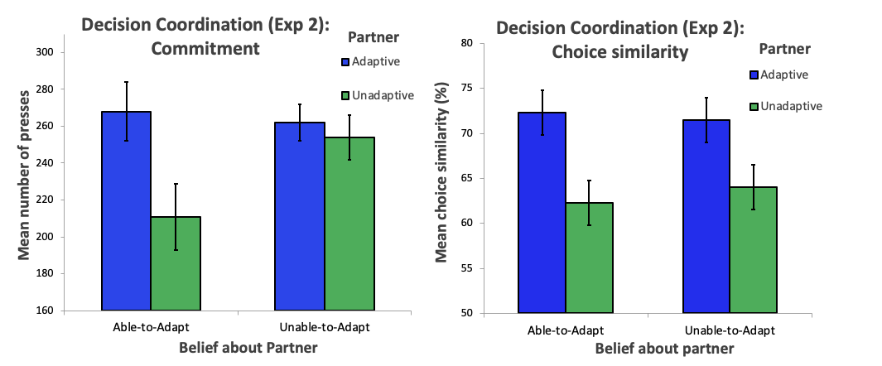

*Graph 2: Left panel displays commitment (indexed by persistence on the charging task) to the adaptive and unadaptive partner in the Able-to-Adapt and Unable-to-Adapt belief conditions. Right panel displays decision similarity (indexed by number of same choices on the object matching task) with the adaptive and unadaptive partner in the Able-to-Adapt and Unable-to-Adapt belief conditions. Error bars represent within-subject confidence intervals.*

**General discussion**

Commitment is a glue holding characteristically human social practices together. When people are committed to a joint action partner or to a group, they are willing to invest time and effort to benefit that partner or that group. The current study aimed to investigate what it is about coordinated social interactions that leads people to develop a sense of commitment towards those with whom they interact. Across two experiments implementing two very different scenarios, we demonstrate that an agent’s investment of effort to adapt movements or decisions in order to ensure successful and smooth coordination fosters a sense of commitment towards that agent.

Thus, our findings provide support for the investment of effort hypothesis: coordination boosts commitment by revealing a co-actor’s willingness to invest effort in order to adapt for the sake of coordination. Indeed, we may conclude that the validity of this hypothesis is highly general, given that we observed the same pattern of results across two experiments implementing two highly distinct scenarios: one involving a task that required physical effort to adapt, and one involving a task that required cognitive effort to adapt.

Crucially the effects of coordination upon commitment which we observed cannot be explained solely by the hypothesis that coordination provides a cue to interpersonal similarity (i.e., the similarity hypothesis). This is because, though we did observe a main effect of adaptivity in both experiments, as predicted by the similarity hypothesis, the interaction between Partner and Belief conditions reveals that the boost which coordination gave to commitment was driven by the inferences participants were led to draw about their partners’ willingness to effortfully adapt to the participant. Moreover, because similarity of timing and of decisions translates to coordination success in the experimental paradigms implemented here(more similarity means less asynchrony and higher rates of same choices) by ruling out similarity we also rule out coordination success as a potential factor mediating the effects of coordination upon commitment.

Nevertheless, it is noteworthy that we did observe that participants persisted more overall for the adaptive partner than the unadaptive partner in Experiment 1. This may suggest that both similarity and effort investment play a role in the emergence of commitment when agents are required to coordinate their actions -- but that similarity does not play such a role in the context of decision-making. This dissociation may provide a clue as to the mechanism by which similarity fosters commitment and other prosocial behaviours in action coordination contexts. For example, the finding that similarity fosters commitment when two agents share perceptual similarity (i.e. temporal synchrony), but not abstract similarity (i.e. having similar perspectives or preferences), suggests that the effects of similarity upon commitment may be driven by low-level processes, such as a low-level merging of self and other [e.g. 11].. Further research should probe further by systematically examining what kinds of cues to similarity are required to yield commitment and other prosocial behaviour.

These findings also present a springboard for further research investigating the mechanisms which lead people to develop a sense of commitment towards those who are willing to invest effort into an interaction. One hypothesis is that, by investing the effort required to adapt, an agent signals that she is a reliable interaction partner, and that it is therefore worth cultivating a collaborative relationship with her. This would explain why participants were particularly willing to persist in order to benefit partners who had demonstrated a willingness to adapt and invest effort. An alternative hypothesis is that an agent’s investment of effort creates a sense of debt or obligation towards that agent, leading to increased persistence in order to ‘repay one’s debt’ [29]. Further research may attempt to disentangle these two hypotheses by implementing one or both of the tasks developed for the current study, and subsequently administering economic games tapping into distinct prosocial motivations. For example, insofar as participants come to view a partner who invests effort as more reliable or trustworthy than a partner who does not invest effort, they should be willing to contribute more money to the pot in a trust game with the willing to invest partner than in a trust game with the unwilling to invest partner [30]. Alternatively, insofar as participants feel a sense of debt towards the willing to invest partner, they may be expected to give more to the willing to invest partner than the unwilling to invest partner in a dictator game.

Moreover, our findings also have broader implications for research into the evolutionary origins and psychological underpinnings of human cooperation. Most of this research (e.g. [31,32]) has implemented monetary incentives in order to probe people’s motivations and attitudes towards cooperation. But as the current study demonstrates, effort is also an important currency for social interaction -- in the same way that those who invest money for the public good are seen as trustworthy [30], we show that those who invest effort may be seen as reliable and competent partners who are worth committing to. It would therefore be important to investigate to what extent findings from research using monetary incentives generalizes to contexts in which the resource that is at stake is effort. More generally, future research should explore how contributions of effort are monitored, compared and exchanged within cooperative activities (e.g. Vilares, Dam & Kording, 2011).

In sum, the current research provides important new insights into the processes by which prosocial motivations such as commitment may arise from the dynamics of real-life social interactions, and opens up novel avenues for research investigating the motivational and cognitive mechanisms underpinning human cooperation in contexts in which the crucial limiting resource is effort -- contexts which would have been the norm in our evolutionary past as they are today.

**Materials and Methods**

**Experiment 1**

The hypotheses, sample sizes, methods, and initial analyses were all pre-registered before data collection. The pre-registration can be accessed at: [*https://aspredicted.org/blind.php?x=bm5dj5*](https://aspredicted.org/blind.php?x=bm5dj5)*.*

*Participants*

Using an online participant recruitment system (SONA: Central European University), we recruited 26 participants for the Able-to-Adapt condition (Sex, M, SD) and 26 participants for the Unable-to-Adapt condition (Sex, M, SD). This sample size was determined, using a g*power analysis, to provide 95% statistical power for detecting a small to medium effect size.

*Apparatus and Stimuli*

Figure 1 provides a schematic of the experimental setup. The participant and the confederate sat in adjacent but connected rooms.

*Drumming task:* In each room, the participant and confederate tapped mounted DDRUM drum pads with a standard drumstick (40cm x 1.5cm). The MIDI input from the drum pads was sent to a PC via a DDTI trigger box, which allowed us to control the sensitivity of the drum pads, as well as the tone they triggered. We also used the box to exclude double taps (taps that occurred less than 100ms between each other), as these were due to the drumstick vibrating on the drum pad being registered as extra taps. The MIDI output was sent to Roland headphones via a focusrite audio interface. Metronome playback and MIDI recording was done in Ableton Live, and stimuli and instructions were presented on PsychoPy 2 (Python 2.7).

*Battery charging task:* The battery charging task was implemented with a custom program using PsychoPy2 (Python 2.7). The program displayed a battery (350x800 pixels), and the avatar representing the partner (100) on the screen. A bar (maximum of 250x600 pixels) representing the battery’s level of power was displayed on the left edge of the battery, and would gradually increase in length (6 pixels every time the amount of presses passed a threshold of *x3*/*y*, where *x* is the amount of 6 pixel units displayed in the battery, and *y* is the amount of presses) as participants tapped the space bar, creating the appearance of the battery filling with power. As the amount of power in the battery increased, the amount of taps required to fill the battery with more power would also increase, making the task progressively more difficult.

*Instructions:* Instructions and the trial structure were all presented on PsychoPy 2. At the start of every trial, the trial and block number were displayed, and then once participants hit the drum, the instructions for that trial were displayed on the screen.

**Procedure**

After providing their informed written consent, participants were informed that they had been randomly selected to play the role of the red player, and would be participating in a two-part experiment, sometimes paired with a blue player, and sometimes paired with a green player. We told participants that they would be seated in separate rooms to their two partners in order to preserve anonymity. Once they had read the instructions, participants were asked to complete a ‘rhythm test’. For this rhythm test, they were instructed to tap at a steady pace, and informed that any participants who received a score below a certain threshold would be excluded from participating in the experiment. This was done in order to ensure that participants believed that their partners were competent, and thus that they would not attribute their partners’ lack of adaptivity to a lack of rhythmic ability. After the rhythm test, we reiterated the instructions and asked participants to complete two practice trials (one with each partner).

Firstly, participants completed a *synchrony task,* which required them to synchronize 32 drum taps with either the ‘blue partner’ or the ‘green partner.’ Both roles were in fact played by the same confederate: this minor form of deception was necessary in order to maintain experimental control, as our manipulations precisely targeted the adaptivity of the partners and participants’ beliefs about the reasons for that adaptivity (or lack thereof). We ensured that one of these partners would be adaptivesimply by allowing the participant and the confederate to hear each other, meaning that they could adapt to each other, thus resulting in similar movement timing. We ensured that the other partner would be unadaptiveby preventing the confederate from hearing the participant; this made it impossible to adapt to the participant, resulting in dissimilar movement timing. Participants completed eight trials with the adaptive partner, and then eight trials with the unadaptive partner. Which of the two (i.e. the blue or the green partner) was adaptive, and which was unadaptive, and the order in which participants synchronized with the adaptive and unadaptive partner was counterbalanced across participants. Between these blocks, participants were instructed to take a short break (~10) minutes whilst they believed that the other participants were completing the task together.

Participants were randomly assigned either to the *Able-to-Adapt belief* condition*, or Unable-to-Adapt belief* condition. In the Unable-to-Adapt belief condition, participants were led to believe that both of their partners could only hear themselves. This was to ensure that they would attribute their ‘unadaptive’ partner’s lack of adaptivity to the fact that their partner could not hear them, and thus refrain from drawing any negative inferences about that partner’s willingness to adapt. In the Able-to-Adapt belief condition, participants were led to believe that both partners could hear them (the participant). This was to ensure that they would attribute the ‘unadaptive’ partner’s lack of adaptivity to an unwillingness to invest effort in the interaction by adapting.

Next, participants completed the *battery charging task,* in which they were instructed to charge on-screen batteries in order to earn points for the partner. They charged the battery by tapping the spacebar for as long as they were willing (up to a maximum of 8000 space bar taps), pressing escape when they wanted to stop charging. They were instructed that the more they charged the battery, the more points they would accrue for that partner. This was completed 8 times for the adaptive partner and 8 times for the unadaptive partner, in an alternating order, with the avatar of the partner whose battery was to be charged being displayed on the screen, along with a power bar that matched the avatar’s color.

**Experiment** **2**

The hypotheses, sample sizes, methods, and initial analyses were all pre-registered before data collection. The pre-registration can be accessed at: <https://aspredicted.org/blind.php?x=5ar3xj>.

*Participants*

As in Experiment 1, we used an online system (SONA: University of Warwick) to recruit 26 participants for the Able-to-Adapt condition (Sex, M, SD) and 26 participants for the Unable-to-Adapt condition (Sex, M, SD).

*Apparatus and Stimuli*

Participants were presented with a screen displaying their own workspace on the top half of the screen, and their partner’s workspace on the bottom half of the screen (see supplementary materials 1). Each workspace contained an array of three Gabor patches (120 pixels) with varying orientations (0-90°), spaced (250 pixels) apart.

The participant’s task was to select a Gabor patch having the same orientation as the one chosen by their partner. Two out of the three Gabor patches in the participant’s workspace had the same orientation as two of the Gabor patches in their partner’s workspace. Thus, there were two possible matches. Participants did not see which Gabor patch their partner chose until after they had made their own decision. At this point, they received feedback in the form of a ring (25 pixels in width) around the Gabor patch that they chose and a ring around the Gabor patch chosen by their partner. On each trial, participants and their partners repeated this procedure eight times, with the aim of coordinating their choices consistently.

The partner’s workspace contained three Gabor patches with highly distinct orientations, making it easy to discriminate among all three of them. In contrast, the participant’s workspace contained one Gabor patch with a highly distinct orientation (the distinguishable patch), and two Gabor patches with similar orientations, which were therefore difficult to distinguish (two indistinguishable patches). Importantly, the oddball had the same orientation as one of the partner’s Gabor patches, and one of the two indistinguishable patches had the same orientation as one of the partner’s Gabor patches. Hence, if the partner selected the Gabor patch which matched the participant’s distinguishable patch, then the partner made coordination easy for the participant. This choice could be considered ‘adaptive’ insofar as the decision was informed by consideration of the participant’s perspective, reflecting an investment of cognitive effort in order to make the task as easy as possible for the participant. This also resulted in the partner preferring similar choices to the participant (assuming the participant had a preference for the distinguishable patch), In contrast, if the partner selected the Gabor patch which corresponded to one of the participant’s two indistinguishable Gabor patches, then the partner made coordination difficult for the participant, forcing them to discriminate between two indistinguishable options. This choice could be considered ‘unadaptive’ insofar as the decision was made without any investment of effort in considering the participant’s perspective. Moreover, this led to the partner having dissimilar preferences to the participant, with regards to which patch to choose. We programmed two virtual agents to act as the two partners. This minor form of deception was necessary in order to maintain experimental control, as our manipulations precisely targeted the adaptivity of the partners and participants’ beliefs about the reasons for that adaptivity (or lack thereof). We programmed the adaptive partner to appear considerate, choosing the Gabor patch which corresponded to the participant’s oddball patch 80% of the time, and choosing the other two options at random. This meant that throughout the trial, coordination was easy for the participant. We programmed the unadaptive partner to prefer the similar patch 80% of the time. Throughout a trial, this made coordination difficult for the participant, as they had to discriminate between two indistinguishable options

As in Experiment 1, participants were randomly assigned to either the *Unable-to-adapt belief* conditionor the *able-to-adapt belief* condition. In the unable-to-adapt condition, participants were led to believe that both of their partners could see only their own (i.e. the partner’s own) workspace. This was to ensure that participants in this condition would attribute the unadaptive partner’s lack of adaptivity to the fact that their partner could only see their own workspace. In the able-to-adapt condition, participants were led to believe that both partners could see both their own and the participant’s workspace. This was to ensure that participants would attribute the lack of adaptivity of the unadaptive partner to an unwillingness to invest cognitive effort in adapting their choices to facilitate the participant’s task.

The battery charging task was the same as in Experiment 1

*Procedure*

As in Experiment 1, participants first provided informed written consent, and were escorted to separate rooms and assigned to the role of the Red player. They were told they would complete a two-part experiment, sometimes paired with the Blue player, and sometimes paired with the Green player. After reading the instructions, participants received some additional on-screen instructions to supplement their understanding of the task. They then started the *decision-making coordination task*, completing eight trials (eight decisions per trial) with the adaptive partner, and eight trials with the unadaptive partner. Before switching partners (i.e. between blocks), they were given a ten-minute break and informed that their new partner had just arrived and would be practicing. After the decision-making coordination task, participants completed the *battery charging task,* which was the same as in Experiment 1.